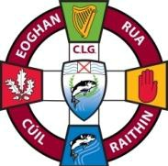 | EOGHAN RUA CLG CUIL RAITHIN  Eoghan Rua GAC Coleraine  Developing and Promoting Gaelic Games

2023 Executive Positions: -

Chairman: Ryan McGeough
Vice Chairman: Damien Mc Laughlin
Secretary: Brian Daly
Assistant Secretary: Joe Diamond
Treasurer: Angela Cassidy
Assistant Treasurer: Vacant
Registrar: Vinty McMahon
PRO: Vacant

2023 Committee:

Ryan McGeough
Damien Mc Laughlin
Brian Daly
Joe Diamond
Angela Cassidy
Cillian Butler
Laurene McMullan
Kevin Mullan
Sean Mc Goldrick
Martin Donnelly
Grainne Mc Goldrick
Barry Mc Goldrick
Aoife Drumm Reynolds
Richard mór Carey
Gerry Lynch
Michael Devine
Hugh Mooney
Brendan McLernon
Mark Cunningham
Aidan Boyle

.

