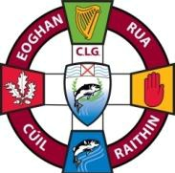 | EOGHAN RUA CLG CUIL RAITHIN  Eoghan Rua GAC Coleraine  Developing and Promoting Gaelic Games | 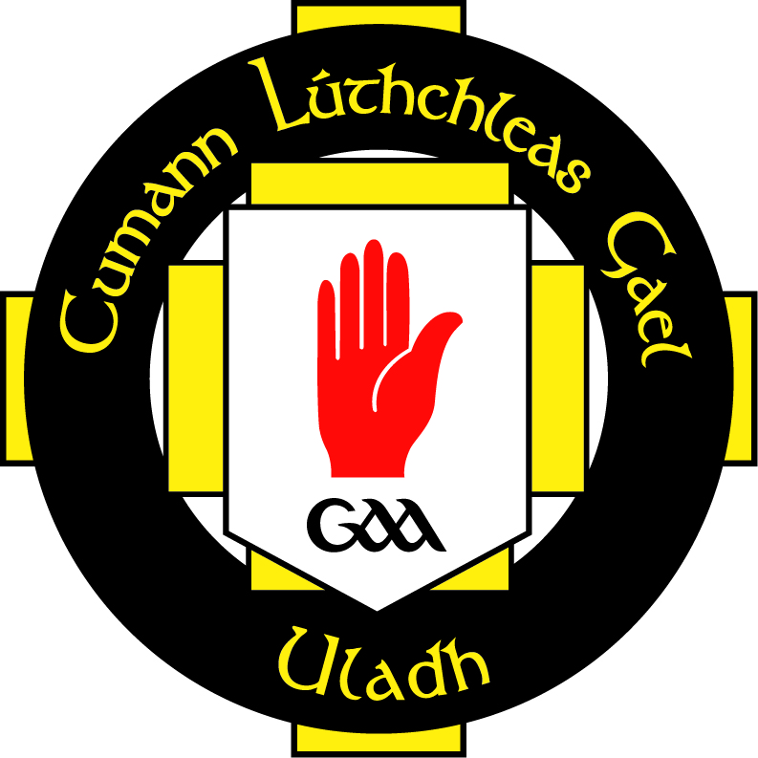

Club Health & Wellbeing Policy
- Eoghan Rua Club values of the health of its members and recognises the role it can play in providing opportunities, information, and education on a range of health issues.
- The Club seeks to ensure that the environment, culture, and ethos within which it runs its affairs is conducive to the continued good health of all its members.
- It is the aim of the Club to use the skills and expertise of both its members and professionals within the community to best promote the Health and Wellbeing Agenda.
Objectives
The Club aims to address the following Health and Wellbeing areas across a range of activities.
Alcohol & Drugs
- The Club has in place a policy to deal with Alcohol & Drug related incidents.
- Club Medal ceremonies for U18s shall not be held where there is an open bar.
- U18’s shall not be taken to pubs on the way home from matches or outings .
- Any cup the Club wins will not be filled with alcohol.
- Jerseys for underage teams will not carry the sponsorship of Alcohol or it’s proprietors.
Smoking
- All indoor areas within the Club are non-smoking.
- There is appropriate signage around the Club to indicate it is a smoke free environment.
- The Club will not house a cigarette machine.
- Coaches of underage teams are not permitted to smoke during training sessions or matches.
- Smoking is not permitted on the Club pitches.
Nutrition
- The Club encourages all players to have their own water bottle.
- The Club encourages all players to bring healthy snacks to trainings and matches.
- The Club will provide information on Sports nutrition for its players via coach advice, Club website, newsletter or talks from experts.
- At Club functions healthy food choices will be provided.
- The Club displays healthy eating posters and leaflets around the facilities.

Mental Health
- The Club promotes mental wellbeing by displaying posters and making available leaflets which raise awareness and offer support to those who may need it.
- The Club fosters an inclusive environment by the rights, dignity and worth of every young person regardless of their gender, ability, cultural background or religion.
- The Club ensures all members sign up to a relevant code of conduct for acceptable behaviour.
- The Club makes available playing or volunteering opportunities for all interested parties.
- The Club links with others in the Community who support the Health and Wellbeing of members.
- The Club knows of relevant services to which it can signpost members if required.
- The Club makes available training or awareness raising opportunities to members.
Road Safety
- The Club supports and promotes Ulster GAA’s Live to Play campaign.
- The Club displays Live to Play campaign posters.
- The Club shares the Live to Play social media messages on its website and Facebook pages.
- If needs arise the Club will host a Live to Play education event involving the emergency services.

First Aid, Cardiac and Injury
- The Club has a number of trained first aiders among its coaches.
- The Club has a defibrillator which is positioned in the clubhouse. A number of club members are trained users.
- The Club defibrillator is maintained by Paddy Morrison every month.
- The Club provides all coaches with a first aid kit for their training and matches.
- The Club physiotherapists are Paddy Morrison and Judith Kelly.

Obesity, Heart Health, Diabetes
- The Club welcomes others from outside it’s structures to use its facilities to increase physical activity levels.
- The indoor hall is available for use such as aerobics classes, yoga, Pilates, dancing etc.
- The perimeter of the pitch provides a safe walking track.
- The Club runs an annual family fun day to encourage all ages to get active.
- The Club provides information for members in the way of posters and leaflets on Healthy Living.
Cancer Prevention
- The Club ensures that members are protected from passive smoking by having its indoor areas as non-smoking.
- The Club encourages its members and players to wear sunscreen when playing in warm weather.
- The Club works in association with the Cancer Focus NI and Irish Cancer Society to provide Cancer information talks.

Signed_______________________________ Date__________________________
Rúnaí
Signed_______________________________ Date __________________________
Cathaoirleach

