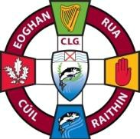 | EOGHAN RUA CLG CUIL RAITHIN  Eoghan Rua GAC Coleraine  Developing and Promoting Gaelic Games | 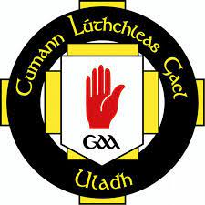

SPEAKING UP POLICY

Background
The GAA aims to promote an open and accountable environment in which malpractice is deterred, stakeholders’ interests are protected, and the good reputation of the organisation is maintained. Eoghan Rua GAC is committed to adopting the National GAA Speaking Up Policy.
In most situations conventional internal reporting lines are sufficient to prevent malpractice. However where suspected fraud, corruption or other malpractice has undermined the Association’s internal controls and lines of reporting, whistle- blowing can be an effective safeguard. This policy sets out the Association’s procedures for facilitating and responding to such “speaking up”.
The intention is to provide an independent, confidential, external channel for early and impartial reporting of concerns. This will help us to identify a potential problem, and deal with it, before it causes significant damage to the Association’s operations and/or reputation.
Scope
This policy covers suspected cases of illegal or unethical conduct by members or units of the GAA. It does not cover employment grievances or consumer complaints.
Commitment
Matters raised by members in the context of this policy will be taken seriously, will be investigated appropriately and, where so requested, can be raised in confidence.
Process
In the first instance the member should raise their concern with an executive officer of the Club Senior Management Executive Committee.
If unable to raise the matter with a Club officer for any reason, the member should raise the matter with the County Secretary or the CEO of the Ulster Council.
If unable to raise their concern in the above manner, or if the risk or wrongdoing has been reported but has not been addressed, a member can contact the GAA “Speaking Up” service at 0800 445033.
A person making a report should be prepared to explain in full the information or circumstances that give rise to their concern even where this cannot be backed up by firm evidence.
Any concern raised will be treated seriously, assessed on its merits, and appropriately investigated. All efforts will be made to give feedback to the individual on the outcome of any investigation, subject to legal or investigatory limits.
Anonymity & Confidentiality
An anonymous report will be investigated. However it is likely to prove much more difficult to fully investigate such a report. In addition, it should not be assumed that the reporting person’s anonymity can be protected. The Association will not be able to provide feedback on issues raised.
A member who prefers to report in confidence should state this clearly at the outset when initially raising the issue. The GAA will not disclose their identity unless required by law. There may be instances when a concern cannot be investigated or resolved without revealing the reporter’s identity. Such circumstances will be discussed with the person before agreeing how best to proceed.
Where member raises a concern in good faith and it is subsequently established that there is no wrongdoing no action will be taken against the individual who raised the matter.
Misuse
Any evidence of misuse of the procedures set out in this policy will be treated very seriously and may result in GAA disciplinary action. Such instances include:
• A member or unit creating difficulties for another member because he/she raising a genuine concern.
• Any attempt to cover up wrongdoing.
• Making nuisance/vexatious claims.

Signed________________________________ Date __________________________

Rúnaí

Signed________________________________ Date __________________________

Cathaoirleach

